Increasing Feline Exposure to Improve Heart Health

Bryanna Nixon
Department of Psychology: University of Nebraska Kearney
PSY 440: Health Psychology
Dr. Bryanna Scheuler
February 14, 2026

Increasing Feline Exposure to Improve Heart Health
Spending time with companion animals has been consistently associated with improved physical and psychological health outcomes. For example, Diesel and Gaston (2025) found that regular feline exposure was linked to improvements in cardiovascular markers, including lower resting heart rate and improved blood pressure regulation. Their findings suggest that tactile interaction, such as petting and grooming cats, may stimulate parasympathetic nervous system activity, contributing to heart health. Similarly, Nixon (2026) demonstrated that couples who incorporated shared pet interaction into their daily routine reported lower stress levels and improved relational satisfaction. The stress-buffering effects of cats appear to be particularly strong during periods of acute stress, as feline companionship may reduce cortisol levels and increase feelings of emotional security (Nixon, 2026). In addition to physiological and relational benefits, pets may play an important role in resilience during challenging life stages. Scheuler et al. (2025) reported that graduate students with companion animals described their pets as a primary source of emotional grounding and routine, which contributed to persistence during academic stress. Collectively, these findings suggest that increasing intentional engagement with cats may positively influence cardiovascular health, stress regulation, and emotional well-being.
While I already live with two cats, much of our interaction has been incidental rather than intentional. I often pet them briefly between tasks or allow them to sit near me while I grade students’ papers, but I rarely dedicate structured time specifically to spoiling them. Given the documented physical and emotional benefits of feline interaction (Diesel & Gaston, 2025; Nixon, 2026; Scheuler et al., 2025), increasing intentional time spent spoiling my cats may enhance both my health and my relationship with them. Additionally, as someone who experiences periodic work-related stress, I am particularly interested in leveraging pet interaction as a preventive coping strategy. Thus, I selected this behavior because it is personally meaningful, feasible, and grounded in research demonstrating measurable health benefits.
SMART Goal
My goal was to increase intentional time spent spoiling my cats to at least 30 minutes per day for five days. I aimed to follow SMART guidelines in setting this goal. To ensure my goal was specific, I defined intentional spoiling activities such as brushing, play sessions, cuddle time, and treat-based enrichment. To ensure it was measurable, I decided to track the total number of minutes spent engaging in these activities each day. I deemed this goal as achievable, because 30 minutes can be realistically incorporated into my evening routine. This goal was relevant, as research indicates that feline interaction may improve stress regulation and heart health, which may improve my experience as a tenure-track college professor (Diesel & Gaston, 2025; Nixon, 2026). Finally, this goal was timebound, as I tracked the behavior change over five days.
Collection Summary
To measure my behavior, I created a daily tracking spreadsheet in which I recorded the number of minutes spent intentionally spoiling my cats each evening, with categories for each type of activity. Spoiling activities were operationally defined as brushing, interactive play with toys, lap time without electronic distractions, and treat-based enrichment activities. Only intentional, distraction-free time was counted. Minutes were recorded in total minutes per day, per category. Additionally, I recorded a happiness rating on a scale of 1 (extremely unhappy) to 10 (extremely happy), to determine if I felt better in connection with the time I spent with my cats.
Prior to beginning the intervention, I rarely spent more than 15 minutes per day with my cats. During the one-week intervention, my average increased to 32 minutes per day. I met or exceeded my 30-minute goal on four of the five days. The day I fell slightly short (26 minutes) occurred on a particularly busy workday. Overall, the intervention week reflected a meaningful increase of 18 minutes per day compared to baseline.
As seen in Figure 1, there was an immediate increase from baseline to Day 1 of the intervention, and the time remained relatively stable throughout the week. The most notable engagement occurred at the beginning of the week, when I reached 36 minutes of intentional spoiling time. Additionally, there is a notable trend between my happiness rating and time spent with my cats. These results suggest that even within a short, one-week window, structured goal-setting and intentional time spent with my cats can improve my health.
Figure 1
Happiness and Feline Exposure
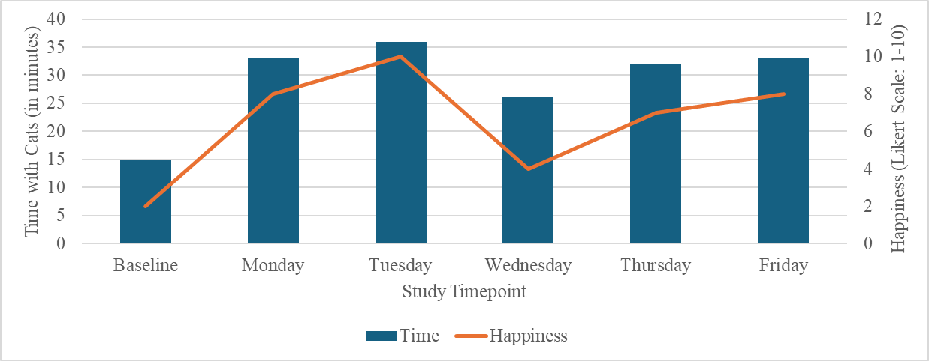
Artificial Intelligence Feedback
To identify strategies for strengthening and sustaining this behavior beyond the five-day intervention, I provided ChatGPT with a detailed description of my goal, tracking procedures, and results (see Appendix A for the prompt and Appendix B for the full response). ChatGPT (2026) suggested several strategies to improve long-term maintenance of the behavior.
One major recommendation was to pair cat-spoiling time with an existing daily habit, such as immediately after dinner, in order to strengthen habit formation through consistent environmental cues (ChatGPT, 2025). Additionally, ChatGPT (2025) recommended tracking daily stress levels using a 1–10 scale to complement the happiness ratings I already collected. Measuring both stress and happiness would allow for a more comprehensive evaluation of the psychological effects of increased feline interaction. The platform also suggested implementing environmental prompts (such as visual reminders) and incorporating a small weekly reward for meeting the goal at least four out of five days (ChatGPT, 2025).
Of these suggestions, I believe that pairing the behavior with an existing routine and tracking stress are highly feasible and would likely improve both sustainability and evaluation of outcomes. Adding a daily stress rating would allow me to directly assess whether the behavior reduces perceived stress, rather than only increasing happiness. However, I do not believe that environmental prompts would be particularly effective for me. Because I already live in a space filled with visible cat-related items (toys, brushes, and cat furniture), I suspect I would quickly habituate to additional visual reminders and fail to notice them. Therefore, while I recognize the suggestion might work well for other people, I would prioritize habit pairing and stress tracking over environmental cues. Overall, the feedback provided a useful framework for refining the intervention and strengthening long-term behavior maintenance.
Project Reflection
Several factors contributed to the success of this one-week intervention. First, the behavior was intrinsically enjoyable, which increased motivation. Second, clearly defining what counted as “spoiling” reduced ambiguity and made tracking straightforward. The act of monitoring my behavior likely increased awareness and accountability, contributing to the immediate rise from baseline.
However, the short duration of the intervention limits conclusions about long-term habit formation. Although I successfully met my goal on most days, I noticed that busy schedules reduced available time. If I were to repeat the intervention, I might lower the minimum daily goal to 25 minutes while increasing the number of required days to six or seven per week to enhance consistency. Alternatively, dividing the 30 minutes into two shorter sessions (e.g., 15 minutes in the morning and 15 in the evening) may increase feasibility.
Overall, this project demonstrated that even a brief, structured intervention can meaningfully alter daily behavior. It also reinforced that intentional engagement with companion animals may serve as a simple, accessible strategy for promoting stress management and emotional well-being. More personally, I learned that I have missed spending time with my cats, and I was shocked to see how much they seemed to be missing me as well. Pets are part of our lives for a relatively short period of time, so I want to make the most of my time with my cats. The fact that spending time with them can improve my stress management is the proverbial icing on the cake.

References
ChatGPT. (2025). Feedback on increasing intentional time spent with companion animals [Generative AI response]. ChatGPT. https://chatgpt.com/c-a-t-s/4.ever
Diesel, C., & Gaston, C. (2025). The impact of feline exposure on heart health. Totally Legit Journal, 12(34), 10–26. https://doi.org/10.00007
Nixon, G. (2026). The cat’s meow: How cats reduce stress in relationships. Other Totally Legit Article, 11(26), Article 11262022. https://doi.org/10.00009
Scheuler, B., Brunett, K., Buccellato, K., Grelle, K., & Groves, C. (2025). The role of pets in surviving graduate school. Yet Another Totally Legit Journal, 11(11), 4–10. https://doi.org/10.00008

Appendix A
For a health psychology class, I attempted to change a health-related behavior. The behavior I wanted to change was increasing the amount of intentional time I spent spoiling my cats each day. The SMART goal I set was to spend at least 30 minutes per day, for five days, intentionally engaging in spoiling activities (such as brushing, playing, cuddle time without distractions, and treat-based enrichment) over a one-week intervention period. To measure the behavior change over seven days, I tracked the total number of minutes spent in intentional, distraction-free interaction with my cats each evening using a spreadsheet. Additionally, I recorded my happiness ratings on a scale of 1-10. I was successful at increasing my daily average from approximately 15 minutes at baseline to 32 minutes during the intervention week, meeting or exceeding my 30-minute goal on four of five days. I struggled with consistency on particularly busy workdays, when I fell slightly short of my target. If I were to repeat the study, how could I improve my approach to make this behavior more sustainable and easier to maintain long term?

Appendix B
Thank you for providing a detailed description of your behavior change project. Based on your results, you demonstrated meaningful success in increasing intentional time spent spoiling your cats, meeting your 30-minute goal on four of the five intervention days. The increase from baseline suggests that self-monitoring and clear goal-setting were effective strategies.
To strengthen and sustain this behavior long term, I would recommend the following evidence-based strategies:
1. Habit Pairing (Behavioral Cueing):
Pair your cat-spoiling time with an existing daily routine (e.g., immediately after dinner or before beginning evening work tasks). Anchoring a new behavior to a consistent cue can strengthen habit formation and reduce reliance on motivation alone.
2. Environmental Prompts:
Consider setting a recurring reminder or placing visual cues (such as leaving a brush or toy in a visible location) to prompt engagement, especially on busy days when time constraints make the goal harder to meet.
3. Track Stress Alongside Happiness:
You are already measuring daily happiness on a 1–10 scale, which is excellent. To better evaluate the psychological impact of this behavior, you might also track daily stress levels using a similar 1–10 rating. Measuring both happiness and stress would allow you to examine whether increased feline interaction not only enhances positive mood but also reduces perceived stress.
4. Flexible Goal Structuring:
On particularly busy days, consider dividing the 30 minutes into two shorter sessions (e.g., 15 minutes in the morning and 15 in the evening). This may increase consistency and reduce the likelihood of missing the goal entirely.
5. Weekly Reinforcement:
Implementing a small reward for meeting your weekly goal (e.g., achieving at least four out of five successful days) may increase adherence and strengthen the behavior over time.
Overall, your project demonstrates that intentional, structured engagement can significantly increase time spent in meaningful activities. By incorporating stress tracking and habit-based strategies, you could enhance both the sustainability of the behavior and your ability to evaluate its psychological benefits.

